.

DCSS Science Fair Handbook



Grade 5

STUDENT SCIENCE FAIR PROJECT TIMELINE outline

You may choose a project which focuses on current class content, or even previews next year’s content. In designing your project, you will answer an original question using in-depth research and a well-planned experiment.

Task | Due Date | Teacher Initials | Parent Initials
1. Choose and submit a problem/question to investigate for teacher approval.
2. Start your log book (Include thinking about a problem/question as your first entry)
3. Conduct preliminary research. (Search for related facts and information)
4. Develop a hypothesis based on your preliminary research.
5. Decide on the procedure that you will use to test your hypothesis.
6. Make a list of your materials. Gather your materials.

7. Conduct your experiment. Collect and record data.

8. Organize your data and results.

9. Write your conclusion based on the results of your experiment.
10. Write a draft of your science fair report.

11. Proofread your draft. Type or write a final copy of your report.
12. Complete your science fair display.

13. Turn in your science fair project (report, log, and display).
2017 District Elementary Science Fair
All events will be at DCSS Annex West

Monday, May 1  (3:00-5:30)  or  Tuesday, May 2  (7:30Am-10:00AM) | Douglas County Schools District Science Fair Setup  Annex West  (Students should place their logbook and any supporting documents on the table in  front of the project)
Tuesday, May 2  (1:30PM-4:00PM) | Project Judging of Displays
Tuesday, May 2  Students should be at  the annex at 4:00PM. | Students’ Interviews in Dogwood Room  and  Parents’ Reception in Magnolia Room
Wed., May 3  5:15PM-6:15PM | Public Viewing of the Projects
Wed., May 3  6:30-7:30PM | Awards Ceremony

*Interview of students will be conducted by judging teams. Students may be excused to leave the Annex once a judging team completes the interview and dismisses the student.

Science Project Components

 | K-2 | 3-4 | 5
Students do background research on the question topic |  | 
Students do an experiment that addresses the question or problem
Students use the scientific method to complete the experiment
Students keep a Log Book

Students complete a research paper

Students create a display for their project
Class Project or large group project
Pairs or individual projects

Science Fair Handbook
Grade 5

Participation:
Projects: Individual and pairs
Teacher-supported throughout the process
How do students select a topic and identify a related problem or question?
Will the project be teacher assigned or will students select from an approved list or will students come up with their own? Consider the information below in making a decision:
- Students should actually design and execute an experiment and collect data. Research topics like black holes are exciting but you can’t get data from this topic.
- Students need to have access to all necessary resources and supplies while doing the project.
- Students must be able to measure some aspect of the topic. For example, in investigating how some factor (like beginning temperature) affects the freezing rate of water, how would you measure freezing time since it is a gradual process?
- Consider using the Topic Wizard at www.sciencebuddies.com to help with topic selection.

What makes a problem or question is acceptable? The checklist below can provide assistance in determining if a problem or question is a good one for a science project. If it is satisfactory, students will be able to do the following:

Checklist to determine if your problem is acceptable
Questions 1-8 should be answered “Yes” & Question 9-11 should be answered “No”
YES | NO | Criteria
 |  | 1. Can the student get measurements or some kind of number for data?
 |  | 2. Can the student measure a change in the variable studied (dependent variable-the variable that may change as a result of changes purposely made in the independent variable)?
 |  | 3. Can the student change the other variable (independent variable-the variable that is changed on purpose by the experimenter)?
 |  | 4. Can the student keep other factors from influencing the results (constant variables-factors in an investigation kept the same; not allowed to change or vary)?
 |  | 5. Can the student collect a lot of data?
 |  | 6. Is it realistic to repeat the experiment at least three times?
 |  | 7. Does the student have time?
 |  | 8. Does the student have all the materials he/she needs, or will he/she be able to get all the materials quickly?
 |  | 9. Is the answer to the question already known?
 |  | 10. Could anyone be even slightly hurt by the project?
 |  | 11. Does the experiment involve humans or animals?
Now that you have identified the problem/question as satisfactory, students will be able to do the following:
- Not know the answer prior to doing the experiment
- Measure a change in the variable studied (dependent variable-the variable that may change as a result of changes purposely made in the independent variable)
- Change the other variable (independent variable-the variable that is changed on purpose by the experimenter)
- Find background information (research) on the subject
- Get enough data
- Be able to get all the materials quickly
- Have time to do the experiment three times

Examples of Topic and Question Development:
TOPIC | VARIABLES | PROBLEM/QUESTION
PLANTS | Germination and temperature | If temperature is changed, will the rate of germination be affected?
BODY TEMPERATURE | Temperature and time of day | Does your body temperature vary with the time of day?
PENDULUMS | Pendulum and its length | Does the length of a pendulum affect its frequency?

BACKGROUND and RESEARCH
What do students include in the background information section of their research report? How do students research their topic?
- The background information should include the following kinds of information:
- History - Has any work already been done on the topic, and what was learned?
- Significance - How is the topic important to us, or how does it make an important contribution to the world around us?
- Facts - What facts are known about the topic and related terms? Define all terms and concepts included in the project. How are the topics/variables related?
- Method - What are ways that this topic can be investigated?

Sources of background information include:
  - books, magazines, and newspapers
  - Internet searches
  - teacher assistance
When doing research, students should look under topics that are relevant or related to the problem/question. For example, they may find nothing on the topic of "paper airplanes", but they will find information under "flight". Students should collect enough information to adequately support their hypotheses and explain their conclusions. The research should be written in the students’ own words; cutting and pasting from the Internet IS NOT acceptable.

HOW STUDENTS DEVELOP A HYPOTHESIS
Somewhere in researching the background information, students should find some indication of what they expect to find happen in their experiment. They should write a specific statement or prediction giving the reasons why they expect this. The hypothesis is a logical and testable prediction about how things work. It should be written like this:
“If ___________ (I do this), then ____________ (this) will happen.” They should also lead to a testable hypothesis (If ______, then ______.), that can be explained through experimentation using the scientific method.
The blanks are filled in with appropriate information related to the specific experiment. It should be something students test and they need to be able to measure both what they do and what happens.
The focus is on applying knowledge of the scientific method. Questions at the fifth grade level should be more complex. Answers to the questions should not be obvious.
Example: Is the strength of a magnet affected by temperature?
This leads to a possible hypothesis like:
“If I heat a magnet, then it will be able to pick up more paper clips than the same magnet at room temperature or when kept in the refrigerator.”

Make sure students identify the following in their hypotheses:
- Independent variable: the variable that is changed on purpose by the experimenter.
- Dependent variable: the variable that may change as a result of changes purposely made in the independent variable.
- Controlled variables: factors in an investigation that are kept the same and not allowed to change or vary (other variables which could affect the dependent variable but which is kept constant)
Example: If I heat a magnet, then it will be able to pick up more paper clips than the same magnet at room temperature or when kept in the refrigerator.

Independent variable-temperature of the magnet
Dependent variable-number of paper clips the magnet picks up
Controlled variables-length of time the magnet is heated or cooled, the size of the paper clips, using new clips after each trial (the clips become magnetized after being exposed to a magnetic field and might affect the outcome of the experiment), etc.

In this case, you would measure both the temperature and the number of paper clips picked up.

How do students design the procedure of their experiment?
How Students Design a Procedure
The procedure should be very clear and precise, written step-by-step. Students should be very specific; they shouldn’t assume that the reader knows how much, how many, or how long. Another person should be able to closely duplicate the project by following the steps in the procedure.
An example of a procedure for the magnet question:
  - Assemble materials.
  - Make a pile of 25 small paper clips
  - Measure the temperature of the magnet at room temperature by laying the bulb of the thermometer against the surface of the magnet and leaving it there for 60 seconds.
  - Record the temperature.
  - Use the magnet to pick up paper clips from the pile. Lift the magnet into the air and hold it there. After 10 seconds count and record the number of clips that stayed connected to the magnet.
  - Put these magnetized clips away. They will not be used again.
  - Repeat steps 2-6 two additional times for a total of three trials.
  - Place the same magnet into the freezer compartment of a refrigerator for 10 minutes.
  - Make a new pile of 25 small paper clips.
  - Measure and record the temperature of the magnet as described in steps 3 and 4.
  - Use the magnet to pick up paper clips from the pile. Lift the magnet into the air and hold it there. After 10 seconds, count and record the number of clips that stayed connected to the magnet.
  - Put these magnetized clips away. They will not be used again.
  - Repeat steps 8-12 two additional times for a total of three trials.
  - Plug in the hot plate and turn it on to medium heat. Let it heat up for 5 minutes.
  - Place the same magnet onto the hot plate. Leave it there for 3 minutes.
  - Make a new pile of 25 small paper clips.
  - Using the tongs, pick up the magnet and lay it on the hot pad. DO NOT TOUCH THE HOT MAGNET.
  - Measure and record the temperature of the magnet as described in steps 3 and 4.
  - Using the tongs, pick up the magnet and use it to pick up paper clips from the pile. DO NOT TOUCH THE HOT MAGNET. Lift the magnet into the air and hold it there. After 10 seconds, count and record the number of clips that stayed connected to the magnet.
  - Put these magnetized clips away. They will not be used again.
  - Repeat steps 15-20 two additional times for a total of three trials.

HOW STUDENTS DEVELOP A LIST OF MATERIALS
This should be a complete list of all materials including details and amounts. Once the procedure is written, students will have a better idea of the materials they will need.
Bad Materials List | Good Materials List
magnet  paper clips  refrigerator  thermometer hot plate | 1 large all-metal bar magnet  225+ small metal paper clips  1 refrigerator  1 metal dry bulb thermometer  1 hot plate with low, medium, and high  1 settings marked  1 hot pad  1 pair tongs 1 stop watch

HOW STUDENTS CREATE A LOGBOOK
Logbooks are used in every aspect of real research as a means of keeping an honest, chronological account of an investigation. Everything students do should be logged. They should begin their brainstorming about topics and problems/questions in their logbook. It should also include the notes students take when they do their research, as well as, all they do as they prepare and carry out the experiment. A logbook is like a journal. Students should write the date at the top of the page. They should make an entry every time they work on their project. They must keep up with it. Students should not go back and write all the entries after they have finished the project.

The logbook should include:
- Paragraph summary of what was done on each day (from thinking about the topic to completing the display)
- Notes that the student took when they did research and the bibliographical information of every source used (include the name of the author, year of publication, title, name and location of publisher, page numbers, website address and the date you retrieved it off the Internet, etc.)
- Labeled drawings or diagrams that help show the reader what was done or what happened on that day
- Any data collected during the experiment
- Any conditions that might have caused unexpected results during the experiment

HOW STUDENTS COLLECT DATA
The experiment needs to result in measurable data. Make sure that all measurements are in metric units: centimeters, grams, milliliters, etc. Not only is this how scientific data is recorded, but eliminates having to use fractions (just decimals should be used).
Students should do a short run of the experiment to see if the procedure works and if it produces the kind of data needed.
- If it takes too long to get data, students should shorten the procedure.
- If something is too awkward to measure, students should change the procedure slightly.
Accurate and precise observations and measurements are important. Sufficient data should be collected that relates back to the hypothesis. There is a tendency to hurry or to forget to record everything that happens. Even data from tests that seem not to work should be recorded. So many projects are ruined because data is lost or good records are not kept. The records and data are the most important and impressive part of the project.

HOW STUDENTS PUT THE DATA INTO A TABLE
The key to starting to interpret or analyze data is a good Data Table. This allows trends and patterns to be easily seen. A good table should have the following parts:
- Title
- Labels for columns and/or rows
- List all units in metric form
Strength of a Magnet at Different Temperatures
Magnet Conditions | Trial #1 |  | Trial #2 |  | Trial #3 |  | Average  Temp | Total # Clips
Magnet Conditions | Temp | # Clips | Temp | # Clips | Temp | # Clips | Average  Temp | Total # Clips
Cooled
Magnet
Room Temperature Magnet
Heated
Magnet

Note: If an Excel spreadsheet is used to make a table, it is already arranged in columns and rows. Then a variety of graphs can be created directly from the spreadsheet. Also, the table and/or graph can be cut and pasted into a Word document. For directions: in Excel, click on “Help” and type in a search for “create a table”.

Website students can use to create tables and graphs:
http://nces.ed.gov/nceskids/createagraph/

HOW STUDENTS CREATE A GRAPH USING THE DATA
As a result of the experiment, data should be collected and organized in both tables AND graphs. Both should have titles and the graphs should have the x and y axes labeled. A key should also be included for the graphs.

Students should be able to explain orally what the tables and graphs show and how they relate to the project.

Examples of graphs:
Remember that the type of data collected will determine the type of graph needed. Data collected for the magnet question is best shown in a bar graph.

 | Type of Data Best Shown in This Type of Graph | Graph
Bar Graph | For comparing 2 to 4 independent groups | 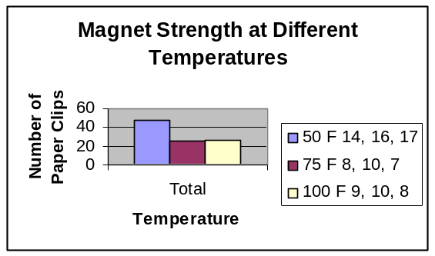
Line Graph | If the independent variable is numerical, and a trend (upward or downward) is indicated | 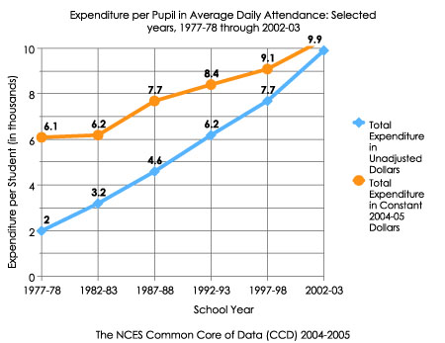
Circle Graph (pie chart) | If graphing parts of a whole (percentages) | 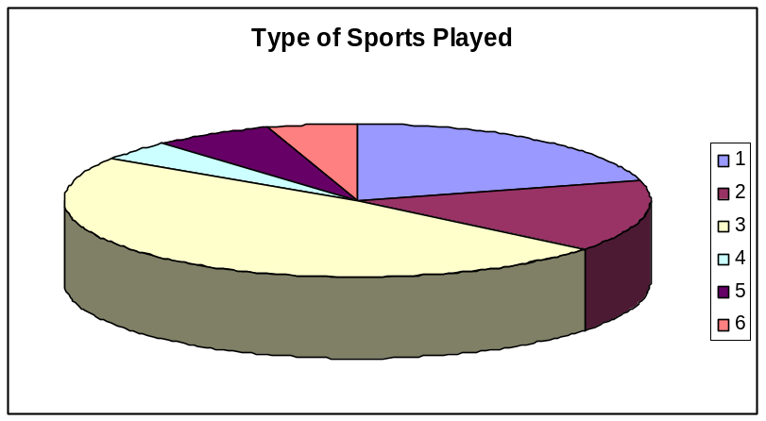
Scatterplot (x-y graph) | When trying to show a possible relationship between 2 variables | 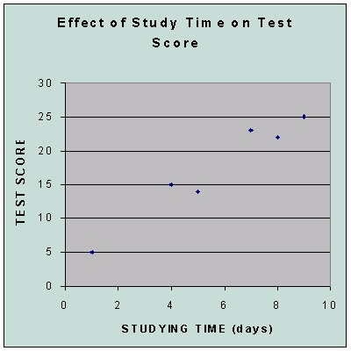

HOW STUDENTS ANALYZE DATA THEY HAVE COLLECTED
After students organize data into a table and select an appropriate graph(s), a written summary of the results should be made by looking at the data and considering these things:
- Does the data show a relationship or reveal some pattern?
- Is there a sizeable or significant difference between any of the groups?
- What possible sources of error are there?
- Did something unexpected (an uncontrolled variable) affect the results of the experiment?

For example, “While conducting the experiment on temperature affecting magnets, a phone call interrupted trial #3. So, the heated magnet wasn’t tested for several minutes after measuring its temperature. The magnet may have cooled considerably before testing it with the paper clips. The number of clips it picked up was somewhat less than on the other two trials with the magnet heated (8 clips compared with 9 and 10 clips).”

For 5th grade Students Only
HOW STUDENTS WRITE THE EXPERIMENTAL RESEARCH PAPER
The report should be written as an informational piece that addresses all parts of the scientific method. Each step in the scientific method can become a sub-heading.
*If students word process the research report, it can be printed twice. The first copy is for the report; the second copy can be cut apart and used for the display board.
Problem/Question
The problem or question is clearly written.
Research
Search for related facts and information is evident (this is the research) and has a direct connection or application to the experiment topic. This section should be a summary of the research in at least one paragraph.
The written material should be in the student’s own words and reflect his/her understanding of the topic (cutting and pasting from the Internet IS NOT acceptable).
Hypothesis
A hypothesis should be written like this: “If ___ (I do this), then ____ (this) will happen.” The blanks are filled in with appropriate information related to the specific experiment

Materials
This is a detailed list of all materials needed to do the experiment, including the amounts or numbers of each item.
Procedures
The procedure should be very clear and precise, written step-by-step. Students should be very specific.
Results/Data
In this section the student include a written discussion of what was observed and recorded during the experiment. Tables and graphs should be included. It is not the conclusion. Things to include in the discussion:
- Does the data show a relationship or reveal some pattern?
- Is there a sizeable or significant difference between any of the groups?
- What possible sources of error are there?
- Did something unexpected (an uncontrolled variable) affect the results of the experiment?

Conclusion

In this section an explanation of what the project proved is written. Consider these things:
- What is the answer to the question based on the data collected?
- Was the hypothesis correct or not?
- Give a summary of what the project shows, relating background reading/research and the data.
- Explain whether the results are significant or possibly affected by error or caused by coincidence. If the data does not show a pattern or if the difference between groups is small, one should say that there was no relationship or difference. This does not mean the project was a failure. Finding that there is no relationship is just as important to science as finding that there is.
- What is the significance of the findings? How could the information be applied (to help others, to make the world a better place, etc.)?
- What are the recommendations for further investigation of the topic?
*If students word process this, it can be printed twice. The first copy for the report; the second copy can be cut apart and used for the display board.
References
All sources used should be listed in APA-style format. If students type in bibliographic information into the website, www.citationmachine.net, it will create entries in APA-style automatically.

HOW STUDENTS CREATE THE DISPLAY
- Students don't have to use a fancy display board; one can be made out of cardboard or poster board.

- The display should be neat, organized, and visually appealing with creative touches.

- It should have a catchy title related to the problem or question.

- All steps of the scientific method should be shown and labeled on the display (question, research, hypothesis, materials, procedure, results/data, and conclusion).

- Photos, charts, and graphs are clear and have direct application to the experiment topic.

*If students word process the research report, it can be printed twice. The first copy is for the report; the second copy can be cut apart and used for the display board.

Appendix

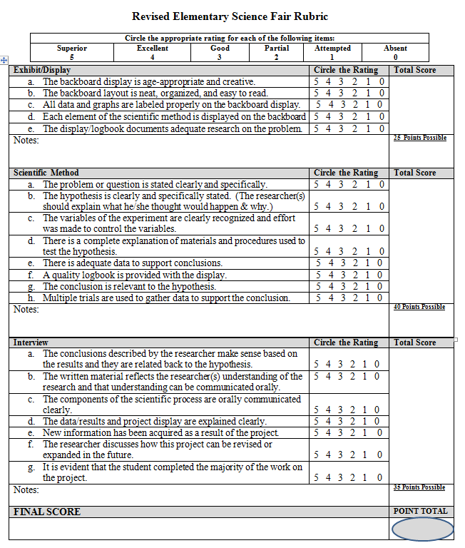

5th Grade Student
Science Fair
Student Handbook

School Letterhead

Science Fair Parent Letter

Dear Parent(s) or Guardian:

The science fair project is an activity that draws upon basic and advanced skills that have been taught and emphasized in your child’s science program. Students generate a problem or question and apply the scientific method to solve the problem or answer the question. Your help may be needed throughout your student’s project. For example, your child may ask for your assistance in the following ways:

• Conducting research via libraries or Internet.

• Typing presentation materials for display.

• Retrieving necessary materials needed for their experiment.

One good cite to visit with your child is www.sciencebuddies.com. This website will help guide you and your child through all components of a science fair project.

Please go over the information presented in this student science fair handbook and discuss it with your child. Some of the details not in the handbook have been or will be discussed in class. Contact me at school with any concerns or questions.

Sincerely,

Fifth Grade Teacher

* * * * * * * * * * * *

I have read the Science Fair Parent Letter.
Date: ______________
Parent Signature: __________________________
Student Name: ____________________________

Fifth Grade Science Fair Project Focus

You may choose a project which focuses on current class content, or even previews next year’s content. In designing your project, you will answer an original question using in-depth research and a well-planned experiment.

STUDENT SCIENCE FAIR PROJECT TIMELINE
Task | Due Date | Teacher Initials | Parent Initials
1. Choose and submit a problem/question to investigate for teacher approval.
2. Start your log book (Include thinking about a problem/question as your first entry)
3. Conduct preliminary research. (Search for related facts and information)
4. Develop a hypothesis based on your preliminary research.
5. Decide on the procedure that you will use to test your hypothesis.
6. Make a list of your materials. Gather your materials.

7. Conduct your experiment. Collect and record data.

8. Organize your data and results.

9. Write your conclusion based on the results of your experiment.
10. Write a draft of your science fair report.

11. Proofread your draft. Type or write a final copy of your report.
12. Complete your science fair display.
13. Turn in your science fair project (report, log, and display).

SCIENCE FAIR EXPERIMENTAL RESEARCH PAPER

PROBLEM/QUESTION
State the problem in the form of a question.

RESEARCH
Do background research to find out what other scientists have discovered about your topic. Your research is a gathering of everything that you did to investigate your selected topic. It contains all the information you collected or learned during the weeks leading up to the actual experiment and science fair. The information you collect can be from and from sources from the library and electronic media. Write this in your own words; cutting and pasting is not an option.

HYPOTHESIS
State your best guess for answering the question before you perform the experiment. The hypothesis is a logical and testable prediction about how things work. It should be written like this:
“If ___________ (I do this), then ____________ (this) will happen.” The blanks are filled in with appropriate information related to the specific experiment. It should be something that you will both test and measure during your project work.
Example:
If I heat a magnet, then it will be able to pick up more paper clips than the same magnet at room temperature or when kept in the refrigerator.
You will measure both the temperature of the magnet and the number of paper clips it picks up.

LOGBOOK
Logbooks are used in every aspect of real research as a means of keeping an honest, chronological account of an investigation. Everything you do should be logged. You should begin your brainstorming about topics and problems/questions in your logbook. It should also include the notes you take when you do your research, as well as, all you do as you prepare and carry out your experiment. A logbook is like a journal. You should write the date at the top of each page. You should make an entry every time you work on your project. Keep up with it. You should not go back and write all the entries after you have finished your project.

Your logbook should include:
- Paragraph summary of what you did on each day (from thinking about the topic to completing the display)
- Notes that you took when you did research and the bibliographical information of every source you used (include the name of the author, year of publication, title, name and location of publisher, page numbers, website address and the date you retrieved it off the Internet, etc.)
- Labeled drawings or diagrams that help show the reader what you did or what happened on that day
- Any data you collected when you did the experiment
- Any conditions that might have caused unexpected results during your experiment
Example of Project Experimental Log:
Date: | Time | Procedures/ Observations

EXPERIMENT

a. MATERIALS

The materials list is a complete list of all materials including details and amounts. Be sure to include quantities (how much), length, volume, and mass. List these in metric units. Be specific in your description of each item.

The Material List should follow these rules:

- Be specific to amount, size and length.
- Listed in metric units where appropriate.

Example of a Material List:

Bad Materials List | Good Materials List
magnet  paper clips  refrigerator  thermometer hot plate | 1 large all-metal bar magnet  225+ small metal paper clips  1 refrigerator  1 metal dry bulb thermometer  1 hot plate with low, medium, and high settings marked  1 hot pad  1 pair tongs  1 stop watch

Fill in the blanks below to create a quality Materials List.
Quantity: | Description of Item:

b. PROCEDURES
List the steps of your experiment. Do not use the words “I” or “you”.

The Procedures should follow these rules:
- Label each step with a number or letter.
- Write your procedures in a step-by-step format
- Be very specific with quantities, amounts and the order that things need to be done or completed.

Example of a Procedure:
The procedure should be very clear and precise, written step-by-step. You should be very specific; don’t assume that the reader knows how much, how many, or how long. Another person should be able to closely duplicate the project by following the steps in the procedure. You should have someone else, who doesn't know what you are doing, read your procedure. The procedure may need to be revised based on feedback from that person to make it more easily understood.

An example of a procedure for the magnet question:
  - Assemble materials.
  - Make a pile of 25 small paper clips
  - Measure the temperature of the magnet at room temperature by laying the bulb of the thermometer against the surface of the magnet and leaving it there for 60 seconds.
  - Record the temperature.
  - Use the magnet to pick up paper clips from the pile. Lift the magnet into the air and hold it there. After 10 seconds count and record the number of clips that stayed connected to the magnet.
  - Put these magnetized clips away. They will not be used again.
  - Repeat steps 2-6 two additional times for a total of three trials.
  - Place the same magnet into the freezer compartment of a refrigerator for 10 minutes.
  - Make a new pile of 25 small paper clips.
  - Measure and record the temperature of the magnet as described in steps 3 and 4.

  - Use the magnet to pick up paper clips from the pile. Lift the magnet into the air and hold it there. After 10 seconds, count and record the number of clips that stayed connected to the magnet.
  - Put these magnetized clips away. They will not be used again.
  - Repeat steps 8-12 two additional times for a total of three trials.
  - Plug in the hot plate and turn it on to medium heat. Let it heat up for 5 minutes.
  - Place the same magnet onto the hot plate. Leave it there for 3 minutes.
  - Make a new pile of 25 small paper clips.
  - Using the tongs, pick up the magnet and lay it on the hot pad. DO NOT TOUCH THE HOT MAGNET.
  - Measure and record the temperature of the magnet as described in steps 3 and 4.
  - Using the tongs, pick up the magnet and use it to pick up paper clips from the pile. DO NOT TOUCH THE HOT MAGNET. Lift the magnet into the air and hold it there. After 10 seconds, count and record the number of clips that stayed connected to the magnet.
  - Put these magnetized clips away. They will not be used again.
  - Repeat steps 15-20 two additional times for a total of three trials.

Fill in the blanks below to create quality Procedures.

Procedures:
1) ____________________________________________________________
2)___________________________________________________________
3)__________________________________________________________
4)____________________________________________________________
5) __________________________________________________________
6)________________________________________________________
7)_________________________________________________________
8)_________________________________________________________
9) _________________________________________________________
10)_____________________________________________________
11)__________________________________________________________

c. DATA
Show what you observed during the experiment. You may use drawings to help show what you observed. As a result of the experiment, data should be collected and organized in tables and/or graphs. Both tables and graphs should have titles and the graphs should have the x and y axes labeled. A key should be included for the graphs. You should be able to explain orally what the tables and graphs show and how they relate to the project.

Website you can use to create tables and graphs:
http://nces.ed.gov/nceskids/createagraph/

d. RESULTS
Tell about your data. Tell about what you observed. Even if your data shows that your guess was not right, your project is still good.
You should organize the data into a table and select an appropriate graph(s) to display that data. You will then write a written summary of the results of the data. Your summary must include:
- Does the data show a relationship or reveal some pattern?
- Is there a sizeable or significant difference between any of the groups?
- What possible sources of error are there?

Did something unexpected (an uncontrolled variable) affect the results of the experiment? For example: “While conducting the experiment on temperature affecting magnets, a phone call interrupted trial #3. So, the heated magnet wasn’t tested for several minutes after measuring its temperature. The magnet may have cooled considerably before testing it with the paper clips. The number of clips it picked up was somewhat less than on the other two trials with the magnet heated (7 clips compared with 9 and 10 clips).”

Your results should follow these guidelines:

- Include what you wanted to accomplish and prove during your experiment.
- Describe and write what you discovered. Be sure to include any data that might have been collected. It is important to show this data even if it did not support your hypothesis. The process of completing the experiment with true data is what is important.
- The purpose of the results section is to present your key results.

Fill in the blanks below to create a quality Results section.

The original purpose of this experiment was to __________________________
______________________________________________________________
_____________________________________________________________

The results of the experiment were _________________________________
_____________________________________________________________
_____________________________________________________________

A possible source of error might be __________________________________
____________________________________________________________________________________________________________________________

e. CONCLUSION
Use one or two sentences to tell about all the results of your experiment. In this section, you will discuss what your project is proved.
- Was your hypothesis correct or not?
- What is the answer to your question based on the data you collected?

DISPLAY BOARD
You don't have to use a fancy display board; one can be made out of cardboard or poster board.

The display should be neat, organized, and easy to read. It should be visually appealing.

The display should have a catchy title that relates to what the experiment is about.

Photograph, pictures, and diagrams may be included to help show what was done.

All parts of the scientific method should be included on the display. Each part should have a label:
- Question
- Research-a short paragraph telling what you learned about the topic through your research (this should be in your own words; cutting and pasting from the Internet IS NOT acceptable)
- Hypothesis
- Materials
- Procedure- with amounts and numbers of each item
- Results-including the tables and graphs that show the data
- Conclusion

SOURCES
List all books, articles, and other sources that you used for your research. You may also interview experts to help with your studies. If you type in your bibliographic information into the website, www.citationmachine.net, it will create entries automatically in APA format.

DCSS Grades 3-5 Science Fair Exhibit/Safety Guidelines

EXHIBIT SPACE: Maximum size is: Width: (side to side) 92 cm (36.in) Depth: (front to back) 76 cm (30 in.) Height: Table Exhibit 92 cm (36 in.)

- Anything which could be hazardous to the public, the exhibitor, or other exhibitors (including sharp, pointed objects) is PROHIBITED
- Organisms: No organisms may be displayed! This includes any vertebrates, invertebrates, fungi, bacteria, or plants. For example:
- No owl pellets, No mice (live or dead), No fish (live or dead), No insects (live or dead), and No skeletons
- Microbial cultures- No bacteria, live or dead
- No Fungi (including bread mold), live or dead
- No parasites, human or other, live or dead
- No live plants are allowed with the display!
- Chemicals: No chemicals may be displayed. For example:
- No acids or bases, dilute or strong
- No salt solutions
- No insecticides or repellents
- No mercury
- No medicines, vitamins, over-the-counter drugs
- No uncovered liquids of any type
- Flammable substances: No flammable substances may be displayed.
- No gases
- No flammable liquids or solid rocket fuel
- No fumes
An alternative solution to displaying the above items: Take photographs of the substances that were used or use a digital camera and create large pictures with a computer printer for display on your board. No identifiable humans or their parts may be displayed in photos.
All projects will be inspected for adherence to Science Fair Safety Guidelines by the classroom teacher or the school Science Fair Committee.

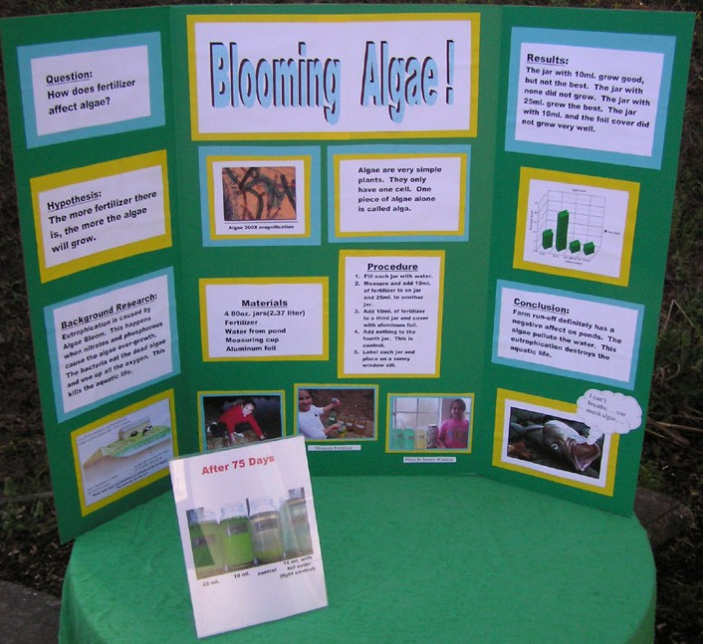

Fifth Grade Science Fair Project Focus

You may choose a project which focuses on current class content, or even previews next year’s content. In designing your project, you will answer an original question using in-depth research and a well-planned experiment.

STUDENT SCIENCE FAIR PROJECT TIMELINE
Task | Due Date | Teacher Initials | Parent Initials
1. Choose and submit a problem/question to investigate for teacher approval.
2. Start your log book (Include thinking about a problem/question as your first entry)
3. Conduct preliminary research. (Search for related facts and information)
4. Develop a hypothesis based on your preliminary research.
5. Decide on the procedure that you will use to test your hypothesis.
6. Make a list of your materials. Gather your materials.

7. Conduct your experiment. Collect and record data.

8. Organize your data and results.

9. Write your conclusion based on the results of your experiment.
10. Write a draft of your science fair report.

11. Proofread your draft. Type or write a final copy of your report.
12. Complete your science fair display.
13. Turn in your science fair project (report, log, and display).

.

